Project Report Template

1. INTRODUCTION
   1. OVER VIEW

Zoho books enable you to manage all your finances in & out your business

Record data easily streamline yur taks and saves your time.

Generate fincial report with just the ckick of a button and track your total receivables ,payable ,revence,expense and collaborate with your finance team in real- team.

* 1. PURPOSE

We recommend zoho book for small to midsize business in online retail space and digital marketing .its user friendly design and simple navigation are attractive to employee new to according.

1. PROBLEM DEFINTION & DESIGN THINKING.

P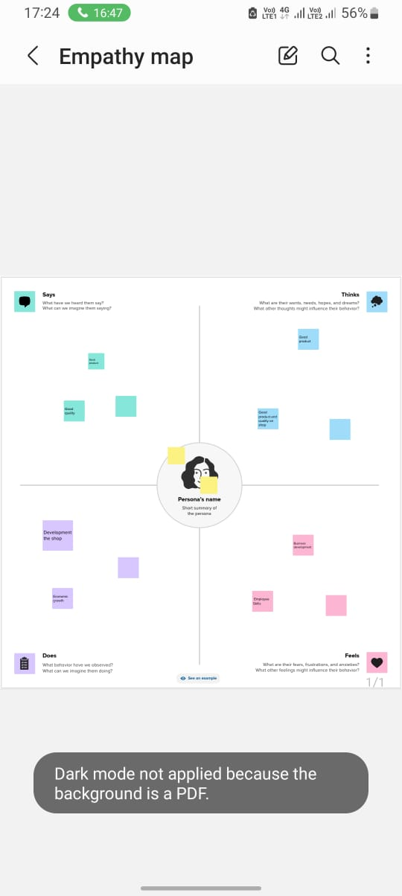

2.2 IDEA & BRAIN STORMING MAP:

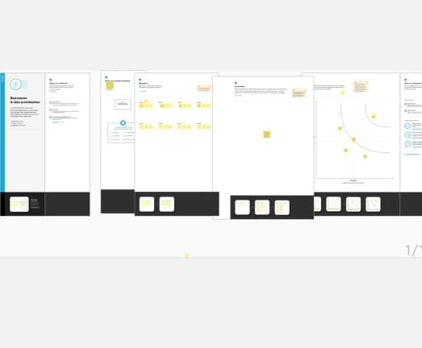

3.RESULT

DASH BOARD

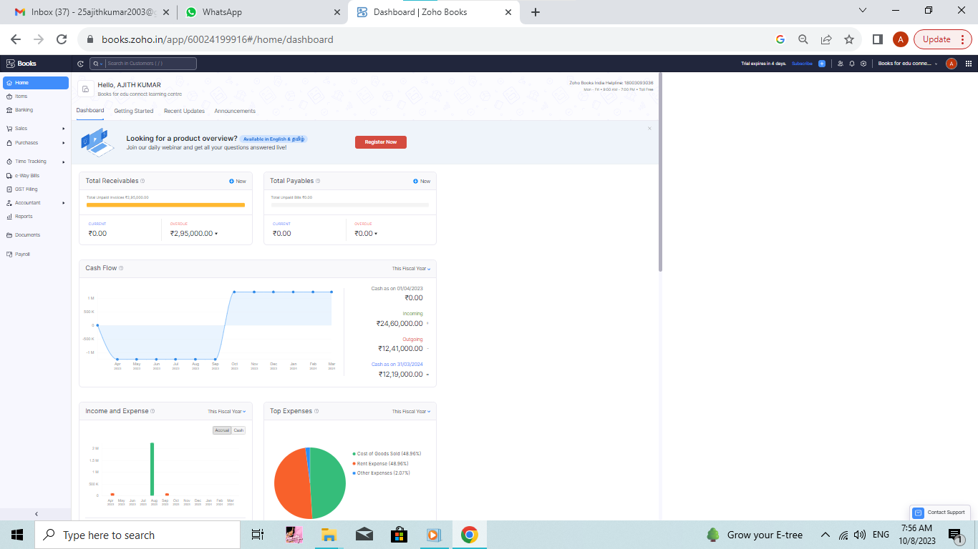

VENDORS

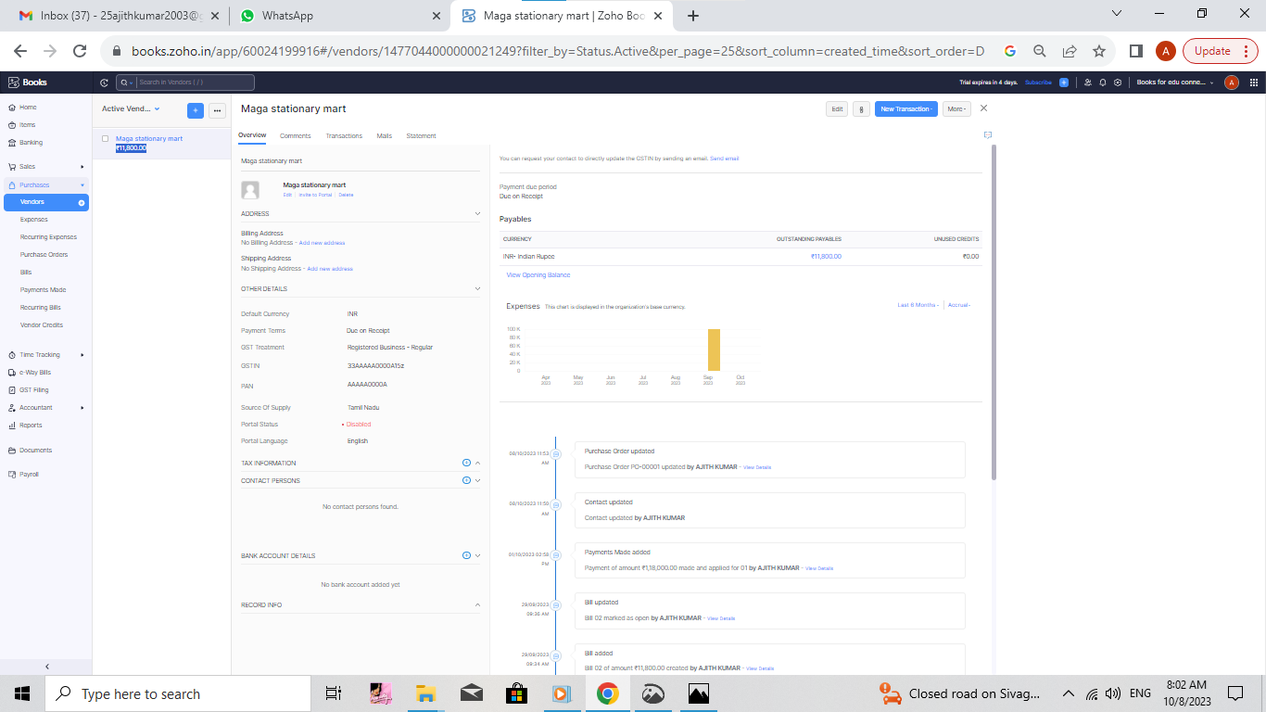

PURCHASES:

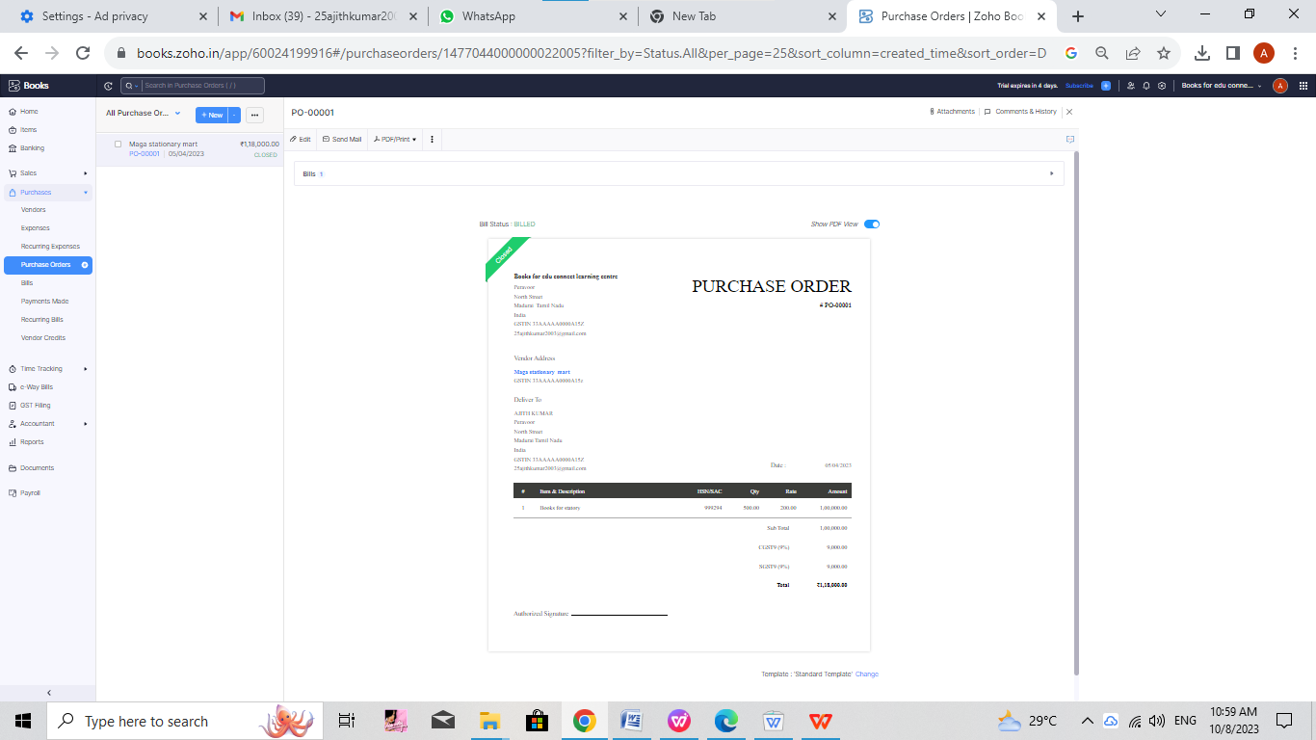

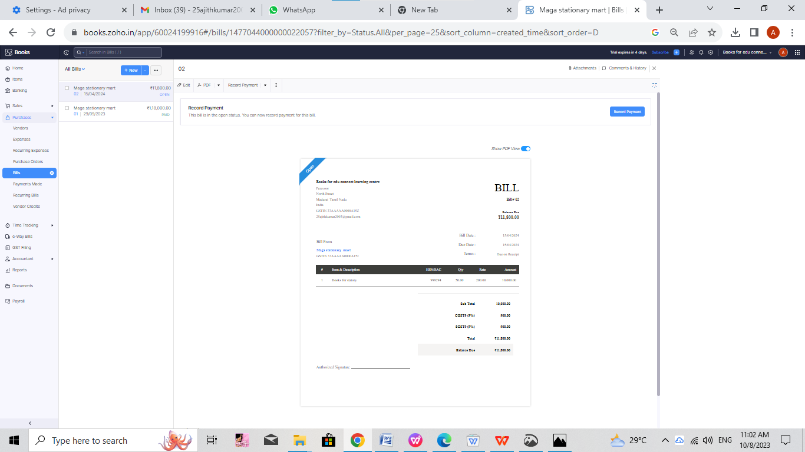

CUSTOMERS:

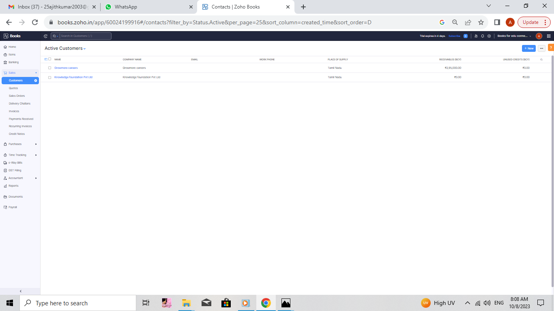

SALES:

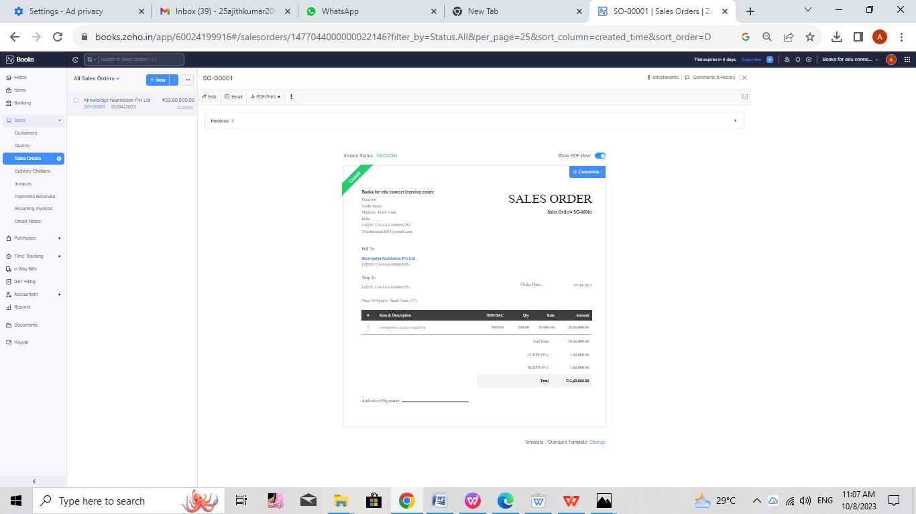

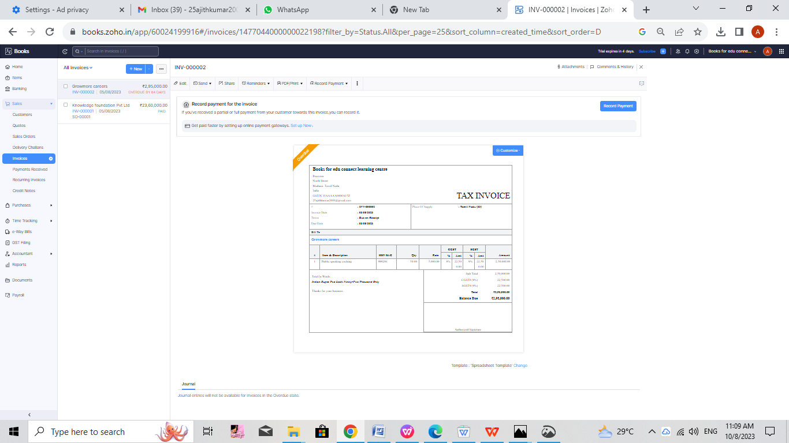

EXPENSES:

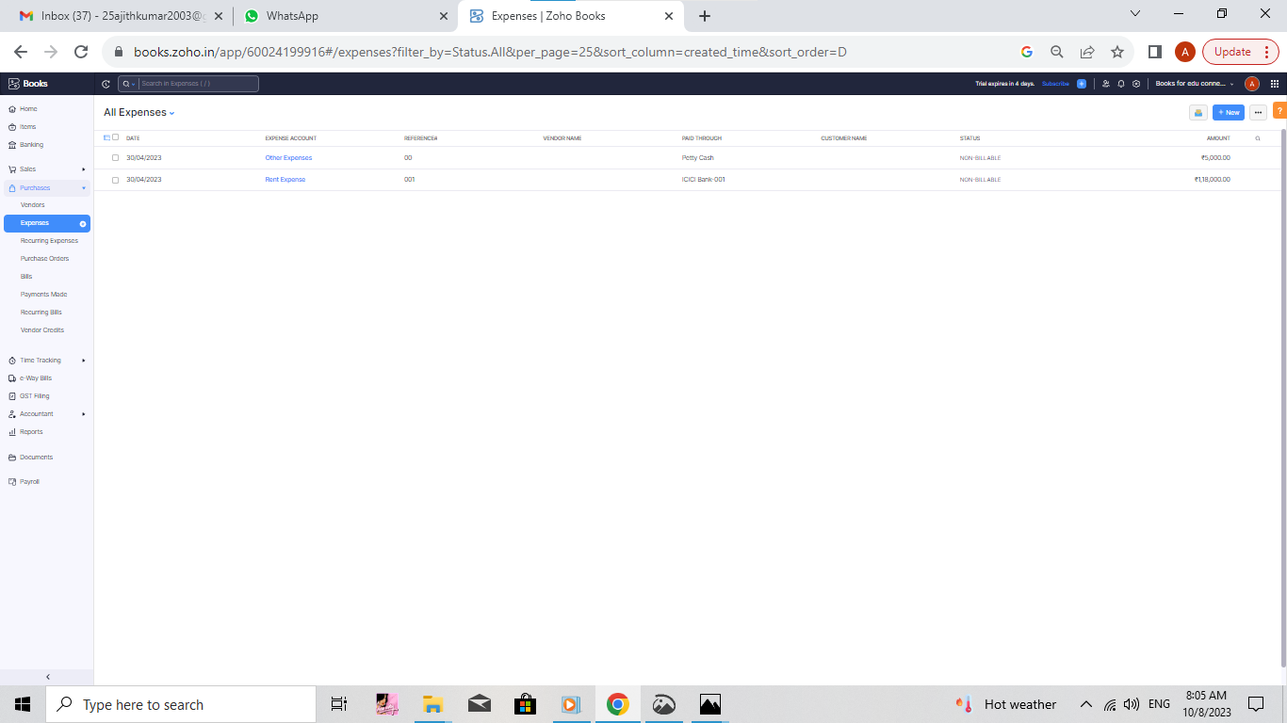

PROFIT AND LOSS:

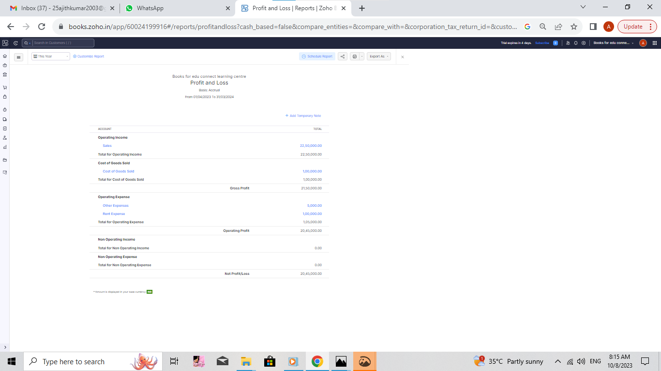

BALANCE SHEET:

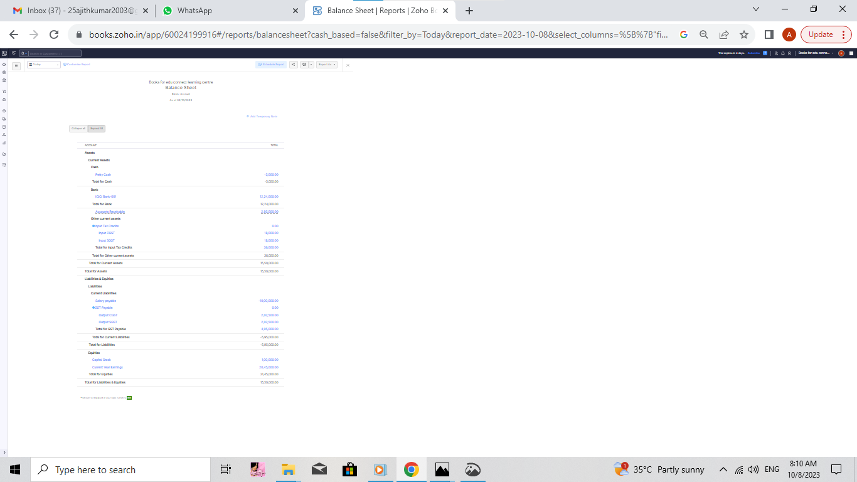

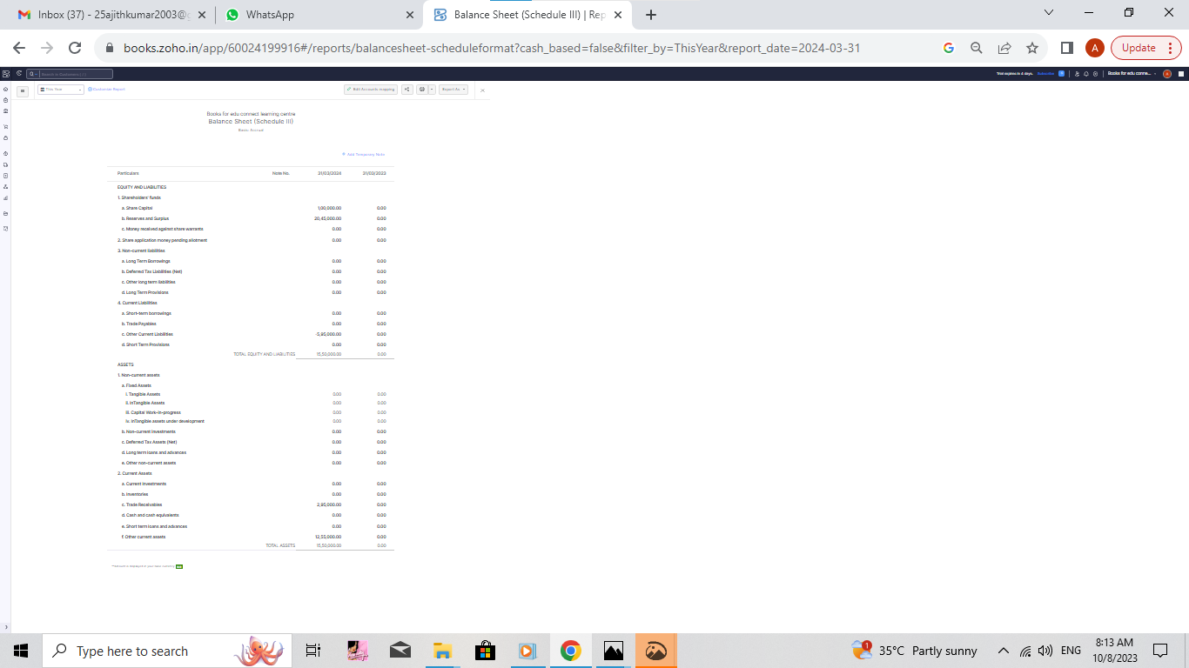

ACCOUNT PAYABLE DETAILS:

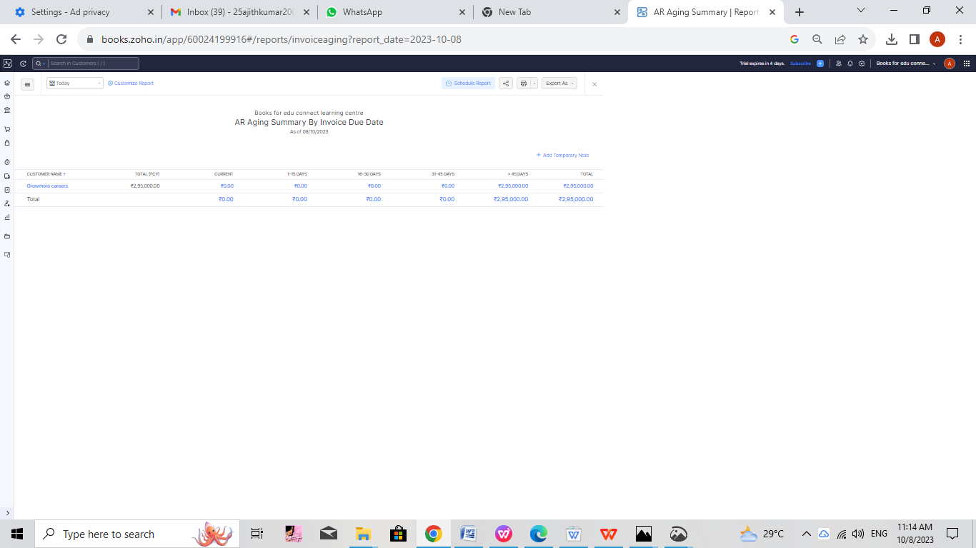

1. ADVANTAGES & DISADVANTAGES:

ADVANTAGE:

ZOHO BOOK IS EASILY TO USE DON”T REQUIRE YOU TO HAVE ANY PREVOIUS EXPERIENCE WITH PRO GRAMMING OR MATHEMATICAL CALCULATIONS.IT DISPLAYS ALL OF YOUR FINANCIAL INFORMATION IN A SIMPLE FORMAT AND OFFERS AUTOMATIONS FEATURES TO SAVE.

DISADVANTAGE:

Zoho books has user limits on all of its paid plans. This can be a disadvantage for larger business that need to give acces to multiple users zoho books does not offer payroll.

6.APPLICATIONS:

Zoho book is an easy to use cloud based accounting software with an invoice b,inventory and project management system. It offer a competive free plan and a variety of features to make your process easier and more efficient.

7.CONCLUTION:

Zoho book is my conclution was it is gave a better experience . and I know how record the transacation in zoho books I am consider zoho book project was like skill development course.

8. FUTURE SCOPE:

Zoho book is highly customizable but there are still some area where business cold bvenfit from more flexibility .in the future we can expert to see even more customization option that allow business to tailor zoho book to their specific needs

Zoho book is a general purpose accounting software but it colud be even more useful for business if it offered industry specific features.